Assignment 3
Topic: Phonebook Using Search Methods

Name: Soham Ajit Puri
Roll. No: 04
Branch: CSDS_C1

Problem Statement: Build a mini phonebook and implement search functionality to find contacts by name using both linear and binary search methods. Compare search time.

- Linear Search:
Purpose
The purpose of this program is to create a simple phonebook application that allows the user to search for a contact by name using the linear search technique. Linear search checks each entry in the phonebook sequentially until the desired contact is found or the end of the list is reached. This method is chosen for its simplicity and ability to work with unsorted data.
How it Works
- Defining the Structure:
  - A Contact structure is created with two fields: name and phone.
  - This allows storing both details together for each contact.
- Storing the Contacts:
  - The program asks the user for the number of contacts (n).
  - A vector of Contact type is declared to store all the entries dynamically.
  - Using a loop, the program takes input for each contact's name and phone number.
- Searching for a Contact:
  - The user enters the name to search.
  - The program starts from the first contact and compares each contact’s name with the search name.
  - If a match is found: The program displays the contact’s name and phone number and stops searching.
  - If no match is found after checking all contacts: It displays “Contact not found”.
- Output:
  - Displays the result of the search, either showing the found contact or a not-found message.

CODE:
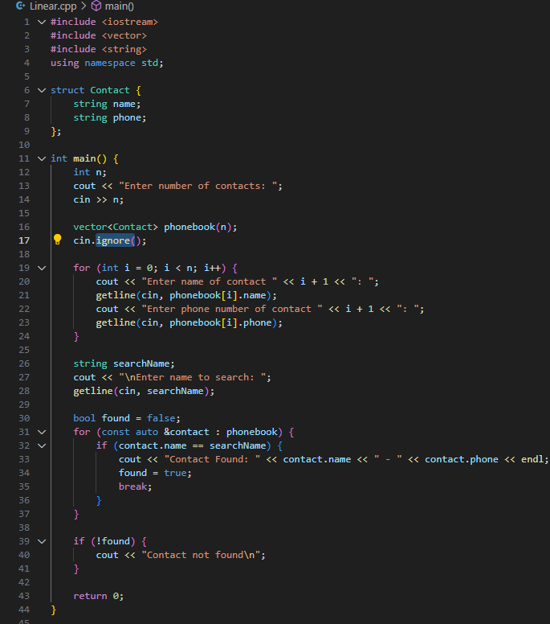

OUTPUT
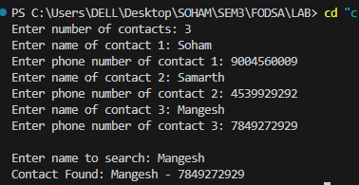

- Binary Search:
Purpose:
This program stores a list of contacts (each with a name and phone number), sorts them alphabetically by name, and then allows the user to search for a contact using binary search. If the contact exists, it displays the name and phone number; otherwise, it shows "Contact not found."
How it works:
- Input Phase:
  - The user enters the number of contacts (n).
  - For each contact, the program takes two lines of input: the contact's name and phone number.
  - The contacts are stored in a vector of Contact structures.
- Sorting:
  - The sort() function from the <algorithm> library is used with a custom comparison lambda to arrange contacts alphabetically by their name.
  - Sorting is essential because binary search only works on ordered data.
- Binary Search:
  - The user enters a name to search.
  - Using two pointers (l for left and r for right), the program repeatedly checks the middle contact (m) of the current range:
    - If the middle contact’s name matches the search name, the program prints the contact's details and exits.
    - If the middle name is alphabetically less than the search name, the search continues in the right half.
    - Otherwise, it continues in the left half.
- Output:
  - If a match is found, it prints "name - phone".
  - If the search completes without a match, it prints "Contact not found".

CODE:

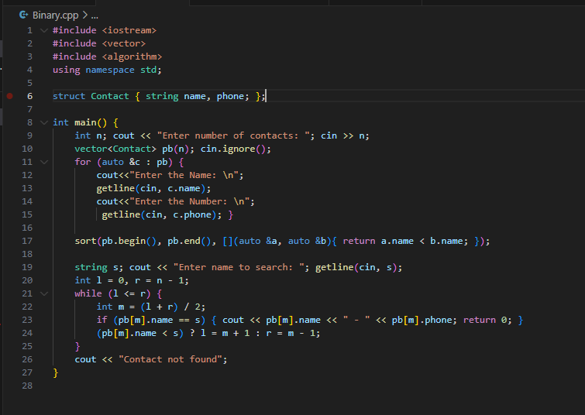

OUTPUT:

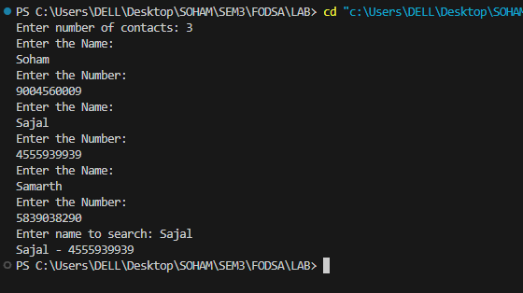

- Using Menu Driven Program:
Purpose:
This program manages a contact list through a menu-driven interface. Users can add contacts, display all contacts, and search for a specific contact by name using binary search. The program maintains contacts in sorted order to ensure efficient searching.

How it works:
- Menu Interface:
  - The program repeatedly shows a menu with options like:
    - Add a contact
    - Display all contacts
    - Search a contact by name (binary search)
    - Exit
  - The user selects an option by entering its number.
- Adding Contacts:
  - The user enters the contact’s name and phone number.
  - The contact is stored in a list (vector of Contact structs).
  - After each addition, the list is sorted alphabetically to keep it ready for binary search.
- Displaying Contacts:
  - The program loops through the contact list and prints all names with their phone numbers.
- Searching (Binary Search):
  - The user enters a name to search.
  - Using binary search, the program checks if the name exists:
    - If found, the contact’s details are displayed.
    - If not found, a “Contact not found” message is shown.
- Exit:
  - Choosing the exit option ends the program.

CODE:
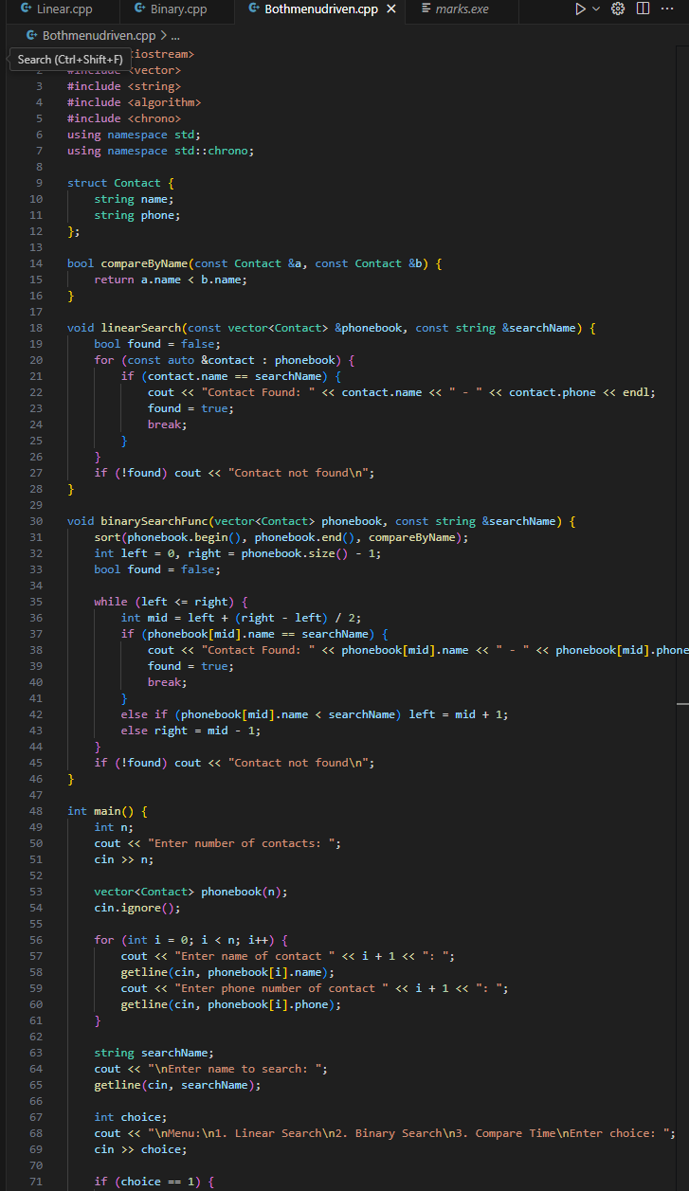

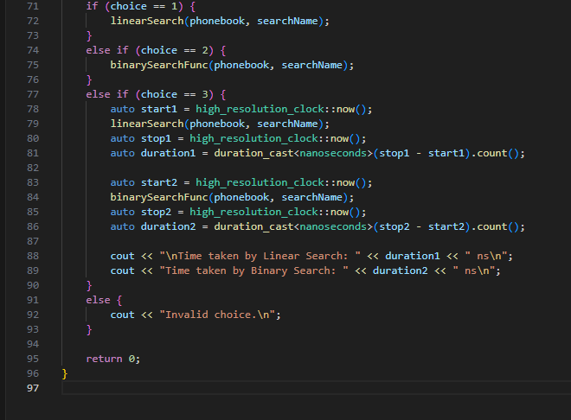

OUTPUT:
